### ****Project Plan: Jay's Fuel****

****Project initial idea design layout****

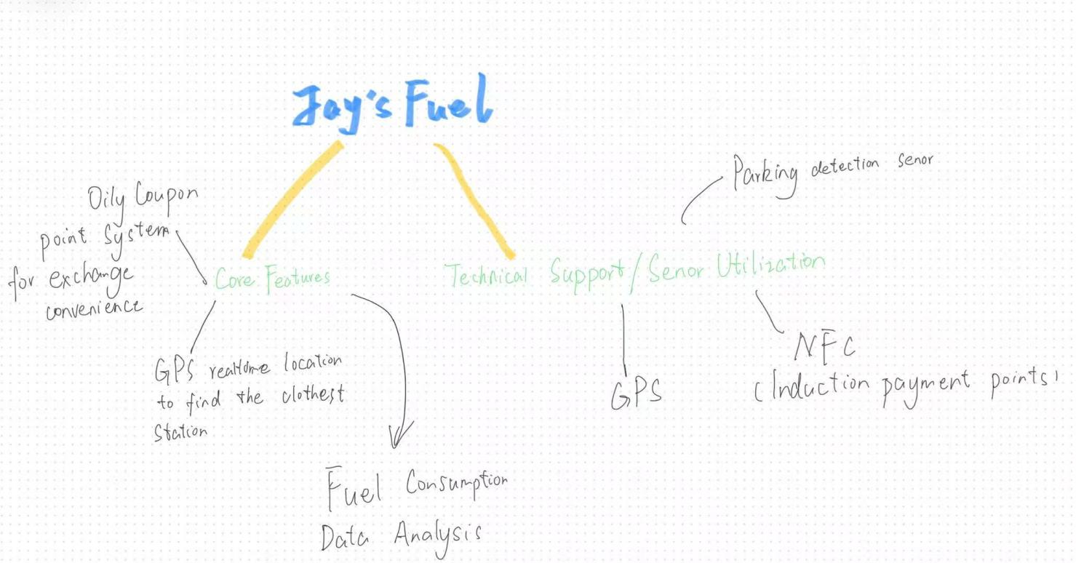

**1. Project Goal**

I will build "Jay's Fuel" - a mobile app to help drivers:

Find cheap gas stations near them

Earn points when buying fuel

Save money with smart driving tips

**2. Main Features & Screens**

| Screen Name | Key Functions |
| --- | --- |
| Fuel Map | - Live GPS map showing nearby stations - Gas price comparison ($/liter) - Navigation to selected station |
| Rewards Store | - Track points earned per fuel purchase - Scan QR codes to exchange points for snacks/drinks - Share points with friends |
| Fuel Hub | - Calculate car's fuel efficiency (km per liter) - Show monthly spending reports - Alert when gas prices drop |

1. **Sensors Used**

GPS (Main Sensor)

·Finds your location

·Guides you to gas stations

·Tracks driving routes to measure fuel usage

NFC (Points Helper)

·Scan NFC tags at stations to collect points

·Tap phone to pay and redeem rewards

·Verify fuel purchases

If phone doesn’t support NFC:

Use QR code scanning

GPS location check instead

**4. Data We Store**

Your Account:

·Car details (license plate, model)

·Favorite gas stations

·Rewards balance

Activity Records:

·Past fuel purchases

·Points earned/spent

·Driving routes (short-term storage)

Settings:

·Fuel type preference (Gasoline/Diesel)

·Low-price alerts

·Dark/Light mode choice

**5. Development Plan**

Phase 1: Basic Map (2 weeks)

Connect to gas station database

Show stations on live GPS map

Phase 2: Core Features (3 weeks)

Build rewards system

Connect NFC/QR scanning

Design Fuel Hub reports

Phase 3: Extra Tools (1 week)

Fuel saving tips generator

Price change notifications